INTER-MILAN BESPOKE TAILOR
CUSTOM TAILOR MEASUREMENT FORM
740 Sukhumvit Road • Bangkok, Thailand • +66 89 665 4940 • pal@inter-milantailor.com
1. PERSONAL INFORMATION

Full Name |  | Date of Birth
Email |  | Phone / WhatsApp
Address |  | Country
Preferred Contact | ☐ Phone ☐ WhatsApp ☐ Email | Client / Order No.
Garment / Occasion |  | Required Date
2. BODY MEASUREMENTS

Please follow the image and instruction for each measurement, then enter your measurement in the box provided.
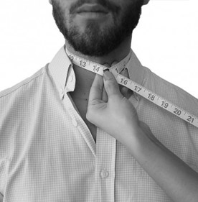 | Neck  Measure around your neck just below your Adam's apple. Leave enough space between your neck and the tape for your collar.  Your Measurement:  ______________________________ Unit: ☐ inches

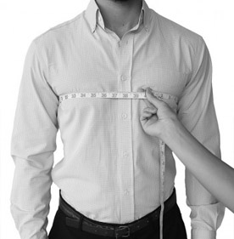 | Chest  Measure around the chest at its widest point. The tape should be tucked high under your armpits and sit approximately at nipple level.  Your Measurement:  _______________________________ Unit: ☐ inches

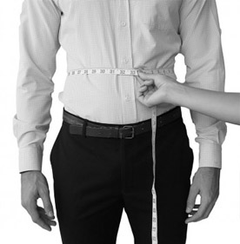 | Waist  Measure around your stomach just above your hip bones. If you have a belly, measure at the widest point and do not pull the tape too tight.  Your Measurement:  _______________________________ Unit: ☐ inches

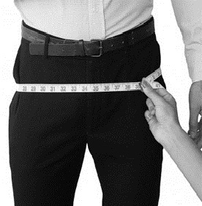 | Hips  Measure around your hips at the widest point, including the hip and buttocks. Do not tighten the tape too much.  Your Measurement:  ________________________________ Unit: ☐ Inches

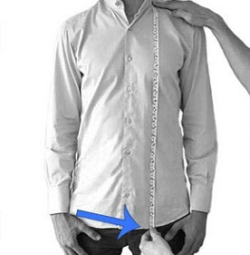 | Shirt Length  Measure from the top of the shoulder near the neck, along the front of your body.  Your Measurement:  ______________________________ Unit: ☐ inches

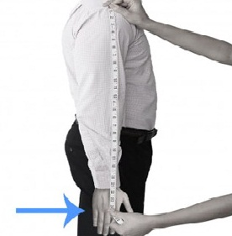 | Arm Length  Measure from the corner where the arm meets the shoulder down to where you want the cuff to finish.  Your Measurement:  _______________________________ Unit: ☐ inches

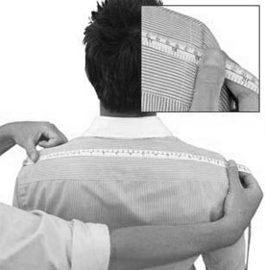 | Shoulder  Measure across the shoulders from one shoulder tip to the other, right on the corner points.  Your Measurement:  ________________________________ Unit: ☐ inches

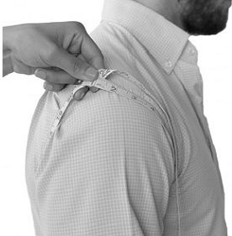 | Armhole  Measure from the top of the shoulder, down the front, under the armpit and back up to the top of the shoulder with ease.  Your Measurement:  ________________________________ Unit: ☐ inches

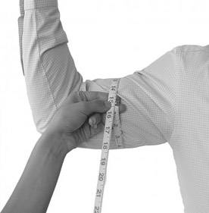 | Bicep  Measure around your upper arm at the widest point. Do not tighten the tape.  Your Measurement:  ________________________________ Unit: ☐ inches

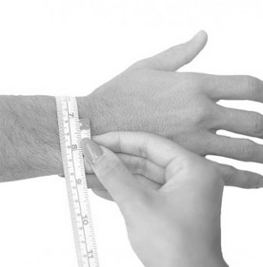 | Wrist  Place the tape around your wrist at the narrowest point. Hold it comfortably and do not make it tight.  Your Measurement:  ________________________________ Unit: ☐ inches

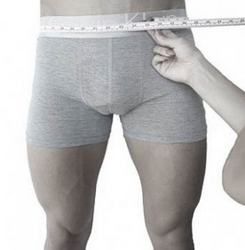 | Pant Waist  Measure around your waist at the point where you normally wear your pants.  Your Measurement:  ________________________________ Unit: ☐ inches

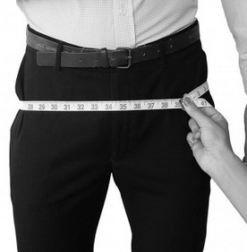 | Pant Hips  Measure around the hip and buttocks at the widest point. Leave enough room to sit and move freely.  Your Measurement:  ________________________________ Unit: ☐ inches

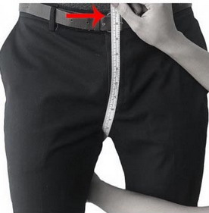 | Crotch  Start at the middle front of your pants waistline, run the tape under your legs and finish at the centre of the back waistline.  Your Measurement:  ________________________________ Unit: ☐ inches

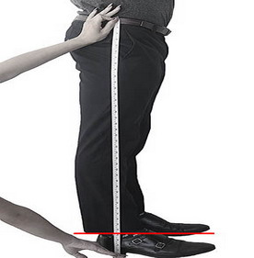 | Pant Length  Measure the full length down the side, starting at the top and finishing at the bottom of your foot.  Your Measurement:  ________________________________ Unit: ☐ inches

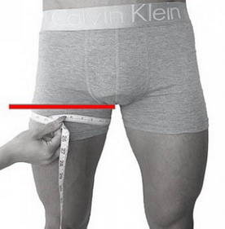 | Thigh  Measure around your thigh as high up the leg as possible, right at the crotch.  Your Measurement:  ________________________________ Unit: ☐ inches

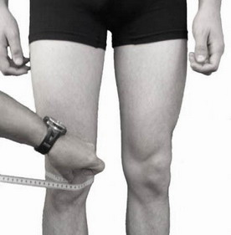 | Knee  Wrap the tape around the knee while keeping the leg straight.  Your Measurement:  ________________________________ Unit: ☐ inches

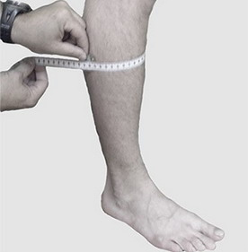 | Calf  Measure around the calf at the widest point, usually about three-quarters of the way down the lower leg.  Your Measurement:  _______________________________ Unit: ☐ inches

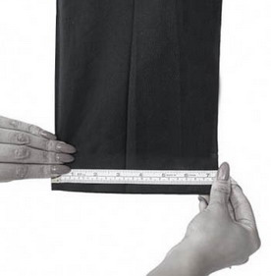 | Pant Bottom  This varies according to trouser style. Measure across the bottom hem of one trouser leg.  Your Measurement:  ________________________________ Unit: ☐ inches

3. STYLE / FIT NOTES

Preferred Fit: ☐ Slim ☐ Regular ☐ Comfort

Garment Details / Style / Fabric / Colour:

Special Instructions or Existing Garment Reference:

Additional Notes:

Inter-Milan Bespoke Tailor • Please save the completed Word document and return it to us.

